# Capstone Project Choice of hotel business location using Foursquare.com

# Business Understanding – Choice of hotel business location

## Background

The start-up of a business in any location requires a lot of corseted effort, data analysis and insight to ensure that the right decision is made, and the benefits are tapped. In today’s world, technology can be implored to assist in making the right decisions in a much faster time. The project is geared towards assisting a start-up business make a crucial decision of which city to locate its business based on having enough local facilities. Looking at the facilities in proximity and other things that could enhance the chances of the business being profitable. There are factors that can impact the choice of business location, like

* Style of operation
* Demographics
* **Foot traffic**
* **Accessibility and parking**
* **Competition**
* **Proximity to other businesses and services**
* Image and history of the location
* Ordinances or zoning restrictions
* The building’s infrastructure
* Utilities and other costs

*Source:* [*https://www.entrepreneur.com/slideshow/299849#10*](https://www.entrepreneur.com/slideshow/299849#10)

Also, the different analysis of the environment can be performed to ensure it looked at all necessary factors. This enable the organisation to make a more informed decision. Other studies and approaches will be considered during the project:

* *Map analysis*
* *Postcode analysis*
* *Travel time matrix analysis*

*Source:* [*https://traveltime.com/blog/business-location-analysis*](https://traveltime.com/blog/business-location-analysis)

In this project, steps are taken to ensure that the data obtained is effectively analysed to ensure that the actions taken are based on a structured and tested basis. The sources of the location and geo-related data is obtained from the Foursquare Website and the focus will be to analyse data from two cities. Steps will be taken to ensure that accurate and an efficient approach is taken to analyse and present the finding on which ideal location should be chosen. Independent of the other factors, the location Manchester and London will be analysed for the purpose of the business start-up.

## Business objectives and success criteria defined

The business objective is to provide an appropriate location for the Hotel start-up business in either location (Manchester or London). Our focus is to provide data insights from the use of the Foursquare website reasons to justify locating a hotel in a city comparing the benefits they provide. With the use clustering algorithms and data science tools, the project will seek scientifically justify the choice of a location.

The success criteria for this project focuses at providing

* A preferred location for start-up hotel business in a specified city or location by extracting data from Foursquare website.
* A recommendation from the analysis.
* *If we are dealing with more than two cities, then the process could be iterative. Then I will seek to adopt following high-level steps –* 
  + *Derive insights based on the location data*
  + *Review the insights and methodology\Algorithm effectiveness*
  + *Evaluate and Measure the effectiveness of result.*

# Data Understanding

This section provides a concise overview of the location data provided from the ‘Postcode’ data and the data provided by Foursquare.com Website for analysis. We have looked at it under the following section providing a holistic view of the data provided.

## Initial data collection and Data description

### Post Code details

The first data source link (*https://www.doogal.co.uk/PostcodeDistrictsCSV.ashx*) consists of Post Code related data and has the following features:

1. ***Postcode:*** *This consist of the outer part of the postcode*
2. ***Latitude:*** *Latitude coordinates of the location*
3. ***Longitude:*** *Longitude coordinates of the location*
4. ***Town/Area:*** *The name of the location or areas*
5. ***Region :*** *This is the location in which the Town or area is within*
6. ***Population:*** *The estimated number of people within that location*
7. ***Nearby districts:*** *Other**postcodes locations within the proximity to this postcode.*

*All the above fields were chosen to provide a framework to enable the analysis and address the business problem. The seven fields were used, and ‘Population’ field was also included to understand the number of individuals within the locality that may patronise and have an impact on the business. Other data fields that were excluded for this exercise are Easting, Northing, Grid Reference,* Postcodes*, Active postcodes and Households for this project. There are about 3,096 records, but the number of records used in the project is dependent upon which cities are chosen.*

### FourSquare.com

The following fields can be extracted from the ***FourSquare.com*** site to enable us extract and use the fields for data manipulation and analysis, with other data that would assist in project.

* ***venue name*** *:**The name of the location with the neighborhood.*
* ***location – (lat, lng)*** *: The geographical location of the venue.*
* ***Distance*** *:**The distance from the ‘venue’ to the point of reference.*
* *Postal Code : The postal code of the ‘venue name’.*
* ***Neighborhood*** *: the description of the location of the ‘venue name’.*
* *City : The city within which the ‘venue name’.*
* *State : The state within which the ‘venue name’.*
* *Country : The country within which the ‘venue name’.*
* ***formattedAddress*** *:**The full address of the ‘venue name’ including post code.*
* *name : A categorical description of the ‘venue location’.*
* *pluralName : A categorical description of the ‘venue location’ in plural.*
* *shortName : A categorical description of the ‘venue location’.*
* *icon : Link to a graphic icon.*
* *photos : Link to a graphic photo.*
* *referralId : Reference.*
* *items : A description of the ‘venue location’.*
* *Type : A high-level description of the ‘venue location’ eg like ‘general’.*

The items in bold indicate that it was used directly within this project.

## Data Exploration

The data from the different sources were explored to understand the respective features and other things related to the data.

Below is a snap-shot of the Postcode sample data:

|  |  |  |  |  |  |  |
| --- | --- | --- | --- | --- | --- | --- |
| **Postcode** | **Town/Area** | **Region** | **Latitude** | **Longitude** | **Nearby districts** | **Population** |
| EC1A | St Bartholomew s Hospital | City of London | 51.5203 | -0.104446 | EC1M, EC3P, EC1N, EC2Y, EC4A, EC1R, EC4P, EC4M... | 878.0 |
| EC2M | Broadgate, Liverpool Street | City of London | 51.5184 | -0.086829 | EC2N, EC3V, EC2A, EC2R, EC3A, EC3M, EC3R, EC3B... | 99.0 |
| EC2N | Old Broad Street, Tower 42 | City of London | 51.5160 | -0.087486 | EC2M, EC3V, EC2R, EC3A, EC3M, EC2V, EC3R, EC3B... | 5.0 |

A snapshot of the regions in the

**Region Counts**

Highland 85

Liverpool 52

Argyllshire 46

Cornwall 46

Birmingham 42

..

Newcastle upon Tyne 1

Hertfordshire 1

Rothes 1

Torridge 1

Ramsgate 1

Below is an extract of data for a location in Manchester from the FourSquare.com website and is used within the project:

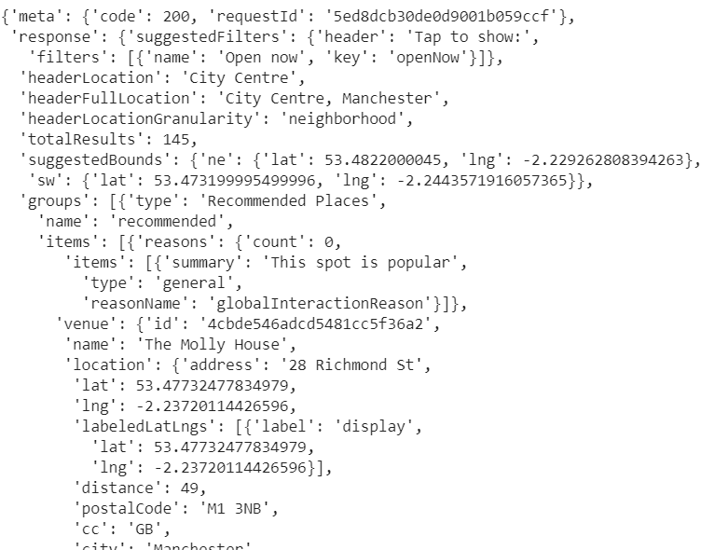

For example, in Manchester we have 100 venues were returned by Foursquare.com, with 11 Hotels for a specific location (53.48, -2.24) that was searched.

The fields associated with geographical location of the cities (‘Latitude’ and ‘Longitude’) was the primary means used to pull the data sources together. Data from FourSquare.com data was extracted from a ‘*json’* format into a python dataset for data manipulation and analysis.

So, the location is used to extract the data for the two independent data sources and then used for analysis, reporting and the various conclusion that will be reached.

## Integrity

The data from Foursquare.com is coming from a reliable source and has been vetted, and the data relating to the postcodes has been reviewed and tidied up where it’s been deemed not suitable for processing.

## Completeness

For the purpose of this project, the data was complete.

## Consistency

For the purpose of this project, the data was consistent

## Accuracy

The data was reviewed and after the removal the ‘*N/A’* values from the dataset, the data was deemed accurate.

# Exploratory Data Analysis

The essence of this section is to explore the data that is available for the two proposed locations for the Hotel.

Using python packages (Folium, Geopy etc.), it is possible to identify both the venues and hotels on the map. Also, the distance from the hotel and venues to the proposed hotel have been obtained and used to inform us in our ability to make decisions.

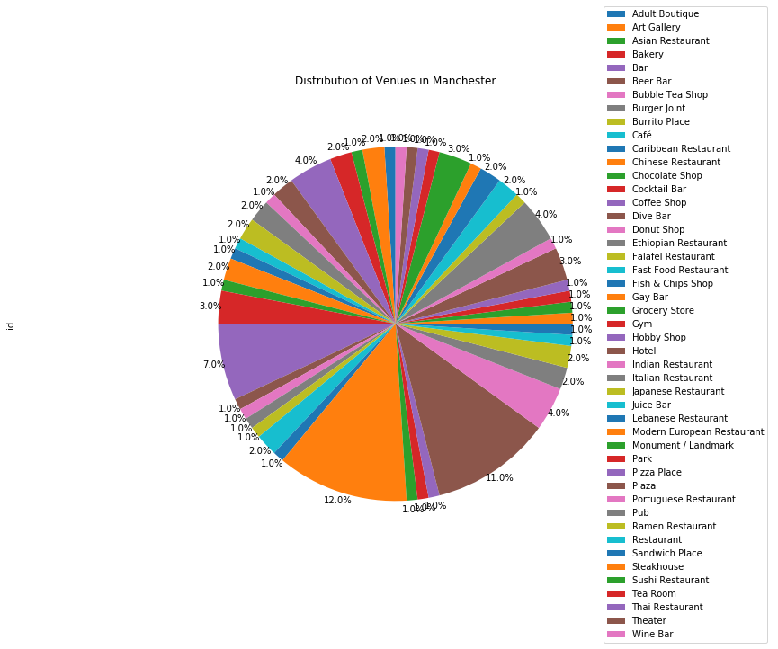

*Fig1 Pie Chart: Distribution of venues in Manchester, with Hotels at 11%,*



*Fig2 Pie Chart: Distribution of venues in London, with Hotels at 5.4%,*

The above provides an overview of the data distribution from the two different location London and Manchester.

So, the charts fig1 & fig2 give an insight of the other venues that surround the proposed location of

the hotel.

# Data Analysis

In the analysis of the data from the different locations under consideration, the focus was to look at the proposed location for the Hotel in the respective locations. And using Foursquare.com data along with the postcode data, extract data from its immediate location as well as neighbouring location to understand the proximity of the following:

1. Existing Hotels that may in competition with the proposed Hotel
2. Other venues within the location that will positively be an advantage to the establishment of the hotel in the location. (Cafes, Supermarket, Gymnastics Gym, Market etc)
3. Using the distance (miles\Metres) gives us an understanding of the proximity of the venues to proposed Hotel location. This data in obtained from the Foursquare.com
4. The focus was to include the Hotel ‘Rating’ of the existing hotels for a comparison, but due to the daily limits associated with the site, it has not been incorporated in this project.

The following provides an insight into the data

**Manchester**

In the selection of Manchester city centre, the of hotels observed in that location were

*Number of Hotels nearby that may be in competition: 11*

*11 Hotel venues were returned by Foursquare for the Manchester location (53.48, -2.24).*

The more hotels that are in that location could have an impact upon the new hotel thriving in that location.

Mean distance of existing Hotels to the proposed location: 288.73metres

Minimum distance from the nearest Hotel to the proposed location: 75metres (*Hotel - Atrium by Bridge street Hotel Manchester*)

It is also observed from that the data gives an insight of venues close to the proposed hotel. This information provides an understanding of either possible challenges or benefits to the hotel. See the table below highlighting the top five venues close, with a hotel indicating a possible challenge.







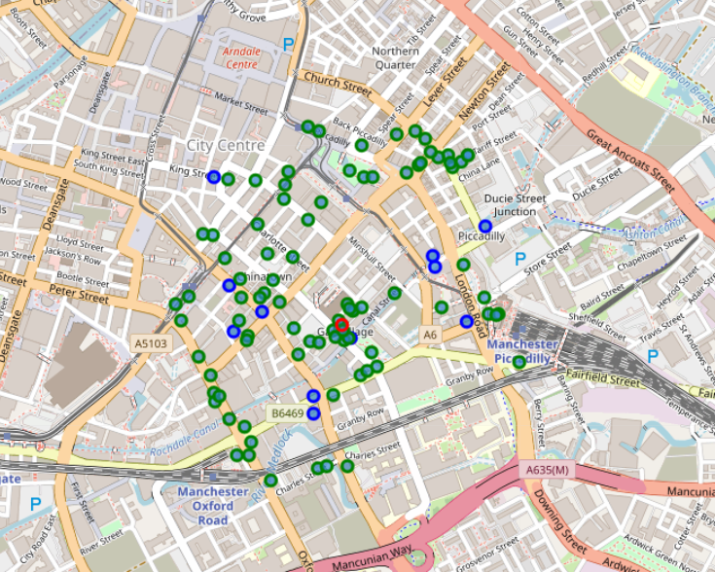

*Blue – Hotel, Green – other venues, Red circle – Proposed Hotel location*

The hotels below showing a fair number of Hotels in proximity to the proposed hotel, which also shows a fair distance from the proposed location. We may infare that the closest (Hotel) competition is more compared to the location chosen for Manchester. There are 454 location and 103 unique Venue categories in the proximity of the propose hotel.

**Venue Perspective**



*The accessibility to local venues****:*** This is seen in the above as the average distance (in miles) from the proposed Hotel location to the Venues (as indicated under the *‘Venue Category*’).

**Neighbourhood Location Perspective**



*The accessibility to Neighbourhoods*: This seen in the above as the average distance (in miles) from the proposed Hotel location to the Neighbourhood (as indicated under the *‘Venue Category*’).

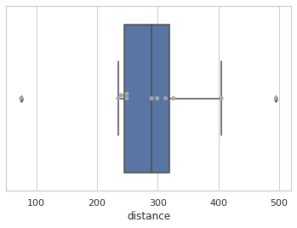

Below show the other venues within the location. These are indicated by the dots in the chart and the distance from the proposed hotel location. So, several the locations are scattered from the proposed hotel location.

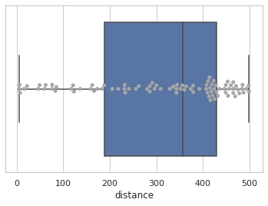

This shows a clustered view of the location using K-Means to derive the clusters in an unsupervised approach. The number of K cluster have been set to 5.

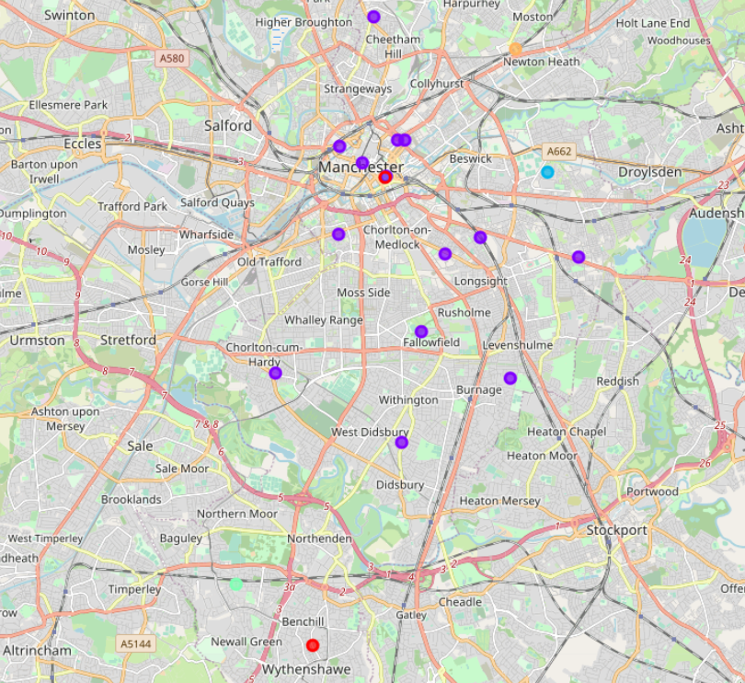

**City of London Data**

The location for the proposed Hotel in London is near St Bartholomew's Hospital with a longitude and Latitude (51.5203, -0.104446) .

Hotel Venues (in competition): 3

3 Hotel venues were returned by Foursquare for the London location.

Mean distance of existing Hotels to the proposed location: 231.33metres

Nearest distance from proposed location: 139 metres (The Rookery Hotel)

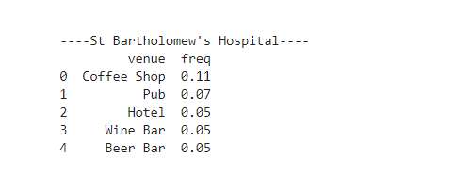



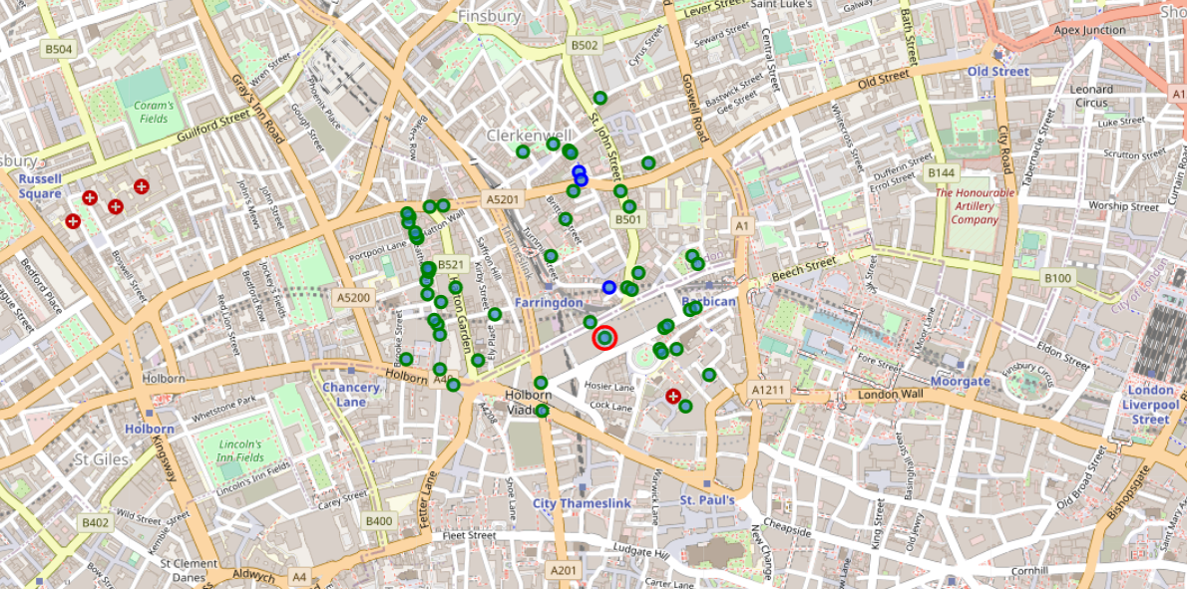

*Blue – Hotel, Green – other venues, Red circle – Proposed location*



The accessibility to local venues: This is seen in the above as the average distance from the proposed Hotel location to the Venues (as indicated under the *‘Venue Category*’).

**Neighbourhood Location Perspective**



The accessibility to Neighbourhoods: This seen in the above as the average distance from the proposed Hotel location to the Neighbourhood (as indicated under the *‘Venue Category*’).

In the boxplot below we see that the only hotel is a distance away from the proposed hotel location. This may imply that there may not be too much competition near the proposed location and that it may be an opportunity to establish the hotel, provided all other factors have been taken in consideration.

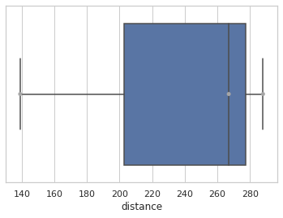

The boxplot below on contrary shows a larger number of the venues at a mean distance from the proposed hotel and therefore accessible to lodgers in the hotel.

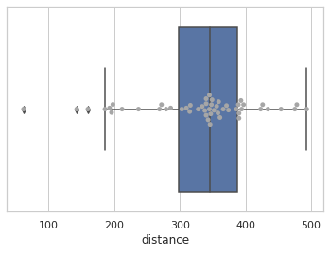

This shows a clustered view of the location using K-Means to derive the clusters in an unsupervised approach. The number of K cluster have been set to 5.

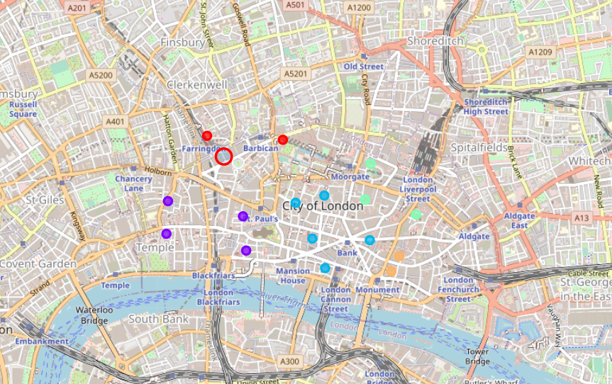

# Conclusion

The location of a Hotel requires a lot more features or factors that can impact the decision of which city to choose. During this project, it is conclusive that it can be used to scout, analyze available venues and facilities that can impact the business to make to the two cities Manchester & London, using the Foursquare.com.